Topic: EXAM011 COMPUTER GRAPHICS - PRACTICAL

Use your computer graphics package to create the following: save your images on this page

(Note: the graphics do not have to be the same size as the ones shown but should be approximately in the same proportion)
1 Boxes
Shading is blue Border is black
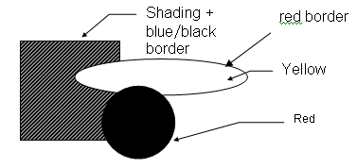
(a)

8 marks

Save your image here

2.Exit
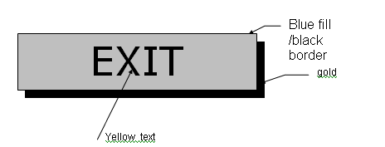

5 marks

Save your image here

3.Box
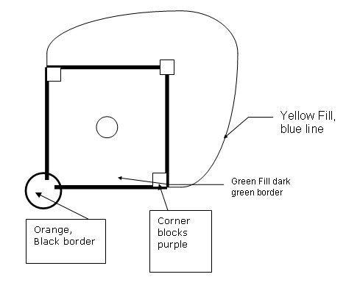

5 marks

Save your image here

Topic: COMPUTER GRAPHICS - PRACTICAL

Use your computer graphics package to create the following: save your images on this page

(Note: the graphics do not have to be the same size as the ones shown but should be approximately in the same proportion)
1 Boxes

(a)

8 marks

Save your image here two samples shown

2.Exit

5 marks

Save your image here two sample shown
EXIT

EXIT

3.Box

5 marks

Save your image here two samples shown
